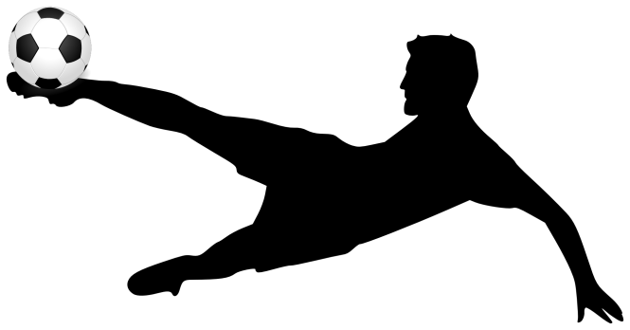

Soccer drills are an important part of progression within the sport, and this booklet contains handpicked drills and games which will help young children progress within the sport. A mix of structure and fun is important for child development as too much of one can lead to boredom or lack of progression. At the end of the day, we all just want to play and have fun!
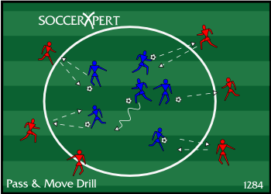
Technique and movement Drill
- Works on basic technique
- Works on fitness
- Communication and concentration
- Coordination and change of direction
This is a good drill to do within most practice sessions, as repetition of this technical drill leads to higher levels of technique and fitness.
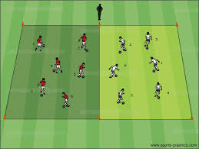
Dribbling and control Drill
- Works on control
- Works on turns to lose defenders
- Works on footwork
This drill is a good drill that works well on memory and footwork as both as tested throughout this drill.
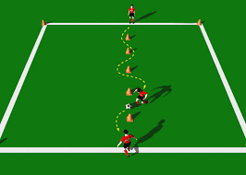
Dribbling Drill
- Control in tight areas
- Use of both feet
- Change of direction
This is a fun drill which can be turned into a game and still obtain the same results. Dribbling through the cones improves ball control and change of direction at speed.

Freeze Tag
- Fun game that keeps everyone engaged
- Works on dribbling and passing accuracy
- Team work
This is a fun game that can take away from the structure of drills. Doing this game after a drill is a good break and will be fun for the team.

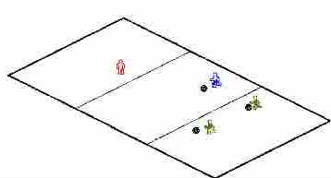
Red light Green light
- fun game breaks up session well
- works on ball control
- teaches to keep head up whilst dribbling
This fun game also can be used to break up the session. It helps the children to follow directions and instructions.

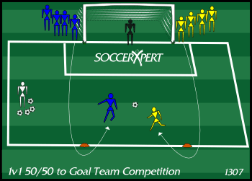
Finishing Drill
- works on 1v1 or 2v2 attacking and defending
- works on ball control and passing
- works on finishing and awareness

This drill is both fun and beneficial. This drill can be turned into a game were two teams are put against each other. This encourages competition and makes it fun for the participants. The calling of the numbers of each player keep them on their toes and ready to be in the game.
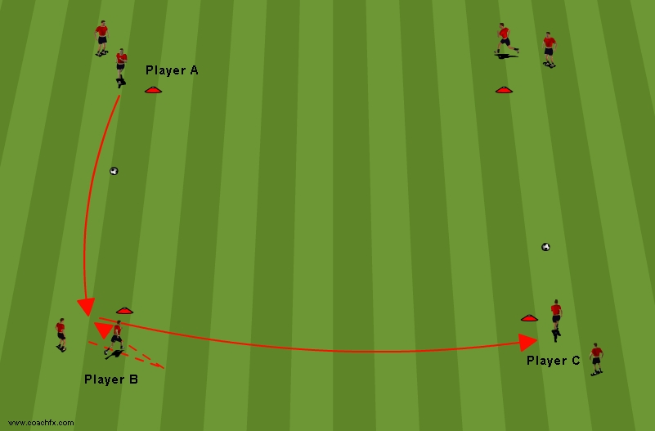
Passing Grid
- works on basic touch and pass
- works on communication and position
- receiving the ball on an angle
- first touch and dribbling

This is a good drill which works nearly every aspect of the game. This is a good drill to do at the beginning of a practice, at is gets the kids warmed up and ready to go. Dribbling, passing, and receiving the ball, is all big parts of the game, and this drill is designed to enhance this aspect.

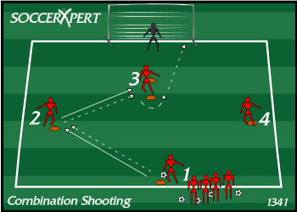
Finishing Drill
- works on basic finishing
- striking the ball and getting a good connection
- aiming for the corners and making the goalkeeper work

this is a basic finishing drill which will help improve the level of finishing within the team. Goal scoring is one of the most difficult aspects of the game, so to have a simple drill with a simple objective can make this easier.

