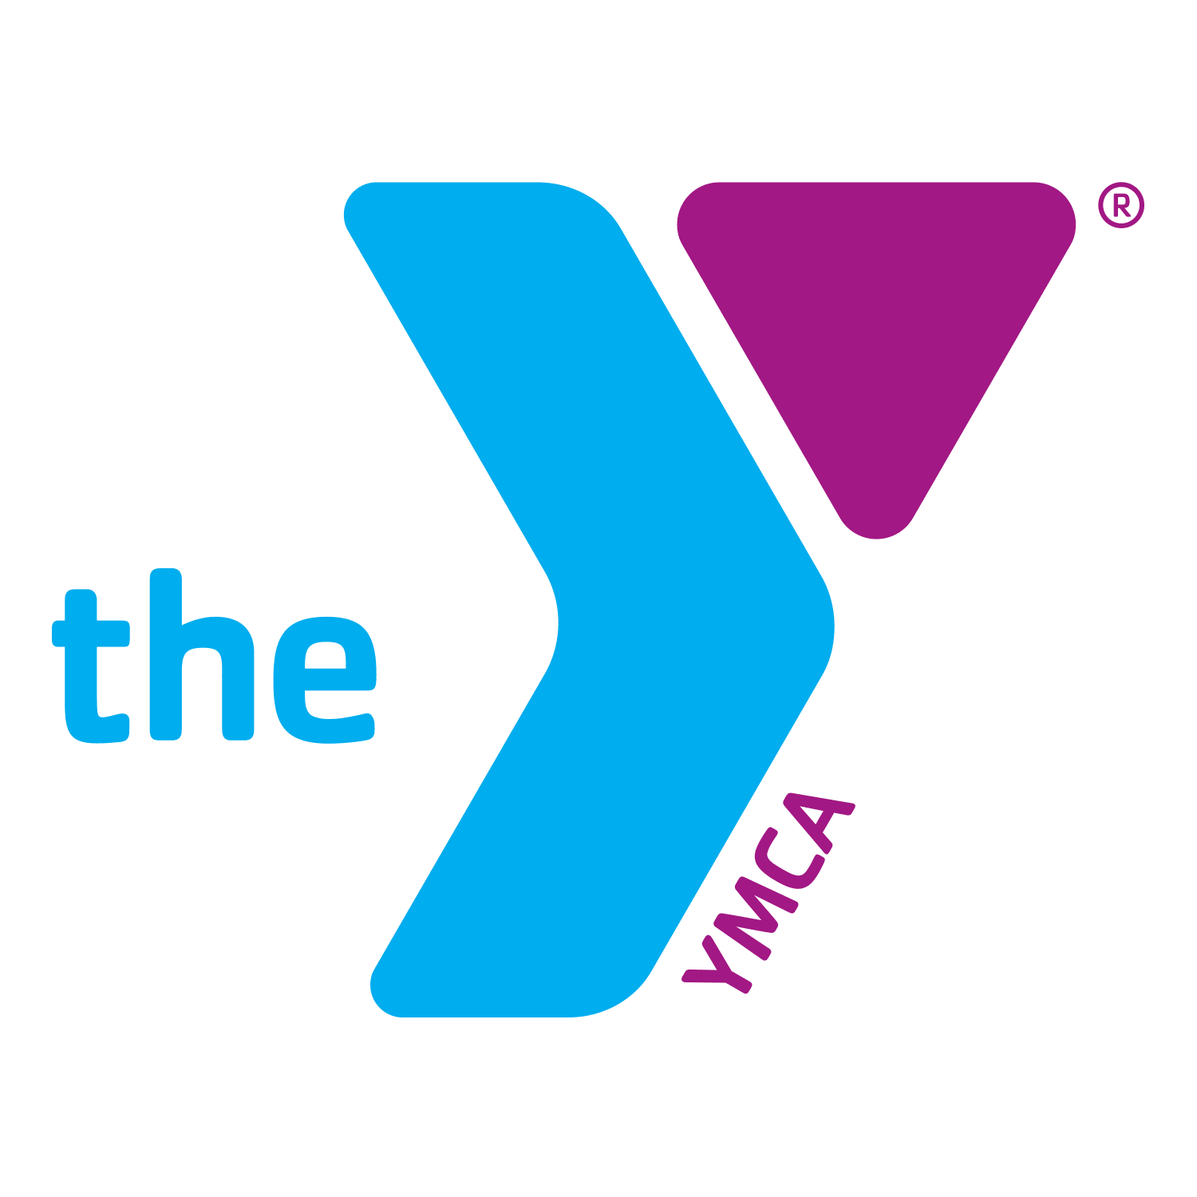
Fitness Class Survey

What class or classes do you attend at the Tiffin Community YMCA?

Are you happy with the day and times of the Class you attend?
Yes No (if circled no, why?)

Are you happy with the duration of the sessions?
Yes No (If circled no, why?)

Is there anything you would change about the classes you have previously, or currently are taking?

What part of our classes do you most enjoy and least enjoy?

What would you like to see in future classes?

Do you have any other comments, questions, or suggestions, about our instructors/ trainers?

