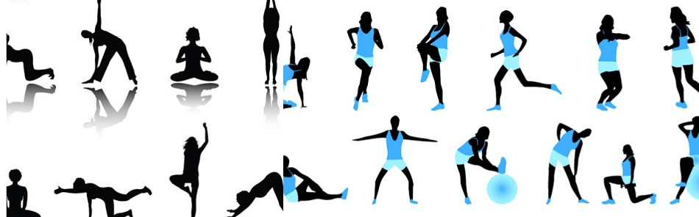
Fitness Instructor Survey
Who was your personal trainer/ fitness instructor?

Please rate overall experience 1-5 by circling the appropriate number (1 being least effective 5 being most effective)
Was it easy to hear and understand the instructor?
1 2 3 4 5
Was the instructor happy, smiling, enthusiastic, etc.?
1 2 3 4 5
Does the instructor vary the session bringing new ideas and creativity to the group?
1 2 3 4 5
Does the instructor do a good job at motivating and keeping the energy levels within the session high?
1 2 3 4 5
Was the intensity of the class satisfactory to your needs?
1 2 3 4 5
Did the instructor’s style meet your needs?
Yes No
If you circled no what would you change?

Do you have any other comments, questions, or suggestions, about our instructors/ trainers?

